Ladies Social Golf Club 2024

Goal of this program is very simple: to have fun while learning the game!  
 Membership is open to all & best of all it is FREE!

No commitments. Join us anytime.

Golf lessons are for all levels & you can decide when you are ready

to join us on the golf course for 9 holes.

When: Every Wednesday Starting May 15th ends in September

Lessons: 4 p.m. – 5 p.m., Complimentary Golf lessons with the Golf Staff

Golf: 5 p.m-7pm 9 Hole Scramble $25 per person inc.lessons,golf,Prizes,

Questions: Pro shop staff can answer all your questions. Call or stop by.

ALL Ladies WELCOME INCLUDING BEGINNERS!!

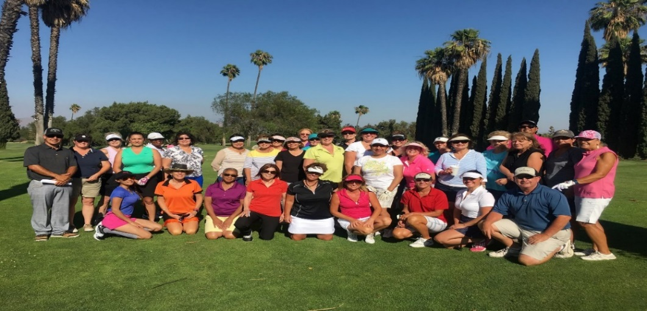

16700 Village West Drive riverside, CA 92518

PH: 951.697.6690

[www.generaloldgolfcourse.com](http://www.generaloldgolfcourse.com)

Follow ladies Social on Instagram @generaloldgolfcourse